**User Manual**

*Eduplan*

**Authors:**

Julio Andrade

Gerald Astudillo

David Bonilla

Tamy Caizapanta

**Introduction**

Eduplan is a digital tool designed to facilitate the management and creation of educational planning in early childhood education centers. This software allows users to efficiently create, view, update, and delete lesson plans through an intuitive CRUD system. Additionally, Eduplan features integrated connectivity with a MongoDB database, ensuring secure, structured, and scalable data storage.

The purpose of this manual is to guide users in the correct use of the system—from logging in to full administration of educational plans—providing a streamlined, modern experience tailored to the pedagogical needs of early childhood education.

# *System Requirements*

**Minimum requierements**

|  |  |
| --- | --- |
| **Processor** | 1 GHz or faster, compatible with PAE, NX and SSE2 |
| **RAM** | 2 GB (64-bit version) |
| **Storage** | 20 GB (64-bit version) |
| **Screen** | **800 × 600 pixels** |
| **Internet Speed** | 1 Mbps |

**Recommended requirements**

|  |  |
| --- | --- |
| **Processor** | Dual-core or higher, 2 GHz or faster |
| **RAM** | 4 GB |
| **Storage** | |  | | --- | | SSD with at least 64 GB of free space |  |  | | --- | |  | |
| **Screen** | |  | | --- | |  |  |  | | --- | | 1366 × 768 pixels or higher | |
| **Internet Speed** | 4 Mbps or more for smooth updates |
| **Java** | |  | | --- | |  |  |  | | --- | | Java Runtime Environment (JRE) 17 or higher | |

# *Installation*

* **Downloading the program**

Request the executable file EduPlan.jar from the developer or download it from the official provided link.

Save the file in an easily accessible folder, such as Desktop, Downloads, or Documents.

* **Installing the Java Environment**

Eduplan requires Java Runtime Environment (JRE) or Java Development Kit (JDK) version 17 or higher.

To check if Java is already installed

Open Terminal (Linux/macOS) or Command Prompt (CMD) on Windows.

Type the following command and press Enter:

**java -version**

If the result shows version 17 or higher, you're good to go.

If not, install Java 17:

Visit the official Oracle website:

<https://www.oracle.com/java/technologies/javase/jdk17-archive-downloads.html>

Download the version corresponding to your operating system (Windows, macOS, or Linux).

Follow the installation instructions.

Restart your computer if necessary.

* **Network Requirements**

For the program to function properly:

* Ensure you have an active internet connection.
* Verify that your device can connect to the domain:

**\*.mongodb.net**

# This domain is used by MongoDB Atlas, the cloud-based service hosting the system’s database.

# **Running the application**

Navigate to the folder where you saved Eduplan.jar.

Double-click the file to launch the program.

Choose one of the following options: Log In, Register, or Exit.

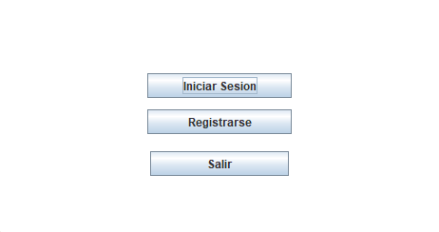

Fill in all required fields correctly to ensure proper user organization. Choose a user type: **Teacher** or **Director**. Only alphabetic characters and spaces are allowed (no special characters, numbers, or blank fields).

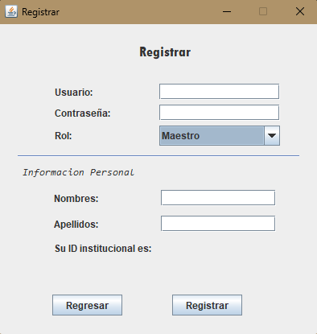

For logging in, enter your username and password accurately to access the system.

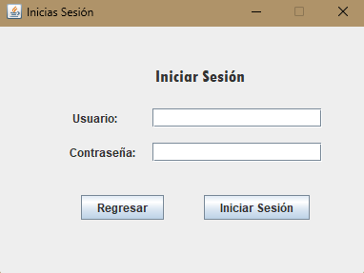

Once logged in, use the top-left menu to access the desired module.

**PLANIFICACIONES MODULE**

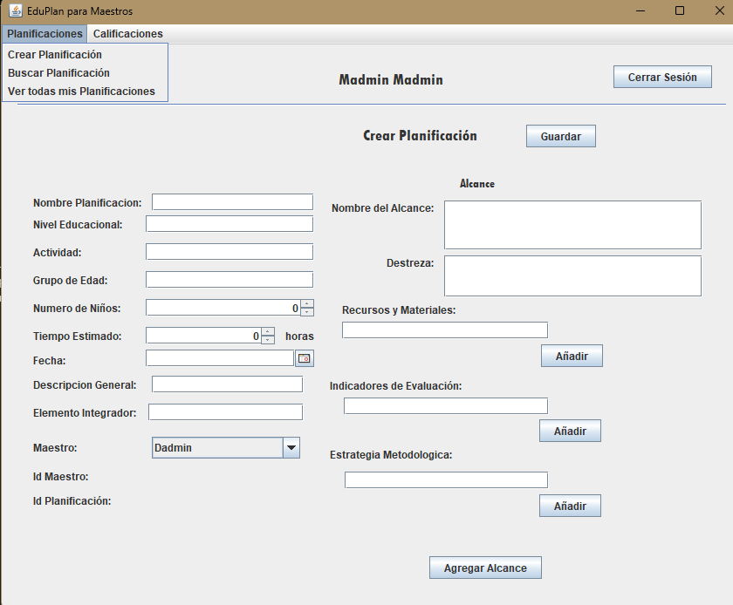

*Crear Planificación*

Fill out all fields. No fields should be left blank to ensure data is saved correctly.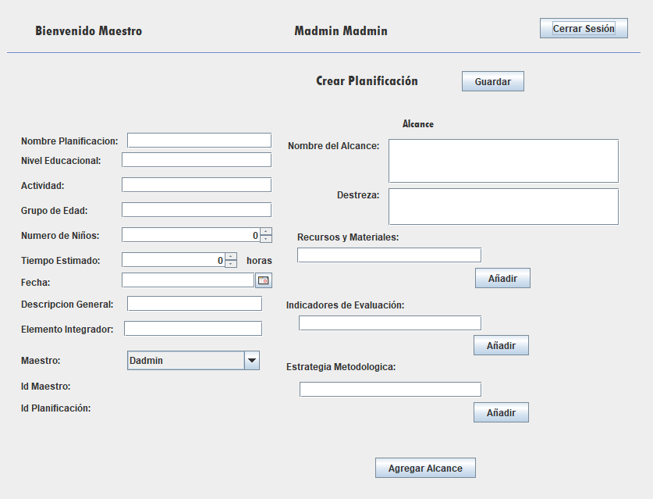

*Buscar Planificación*

Select the plan you want to view from the search options.

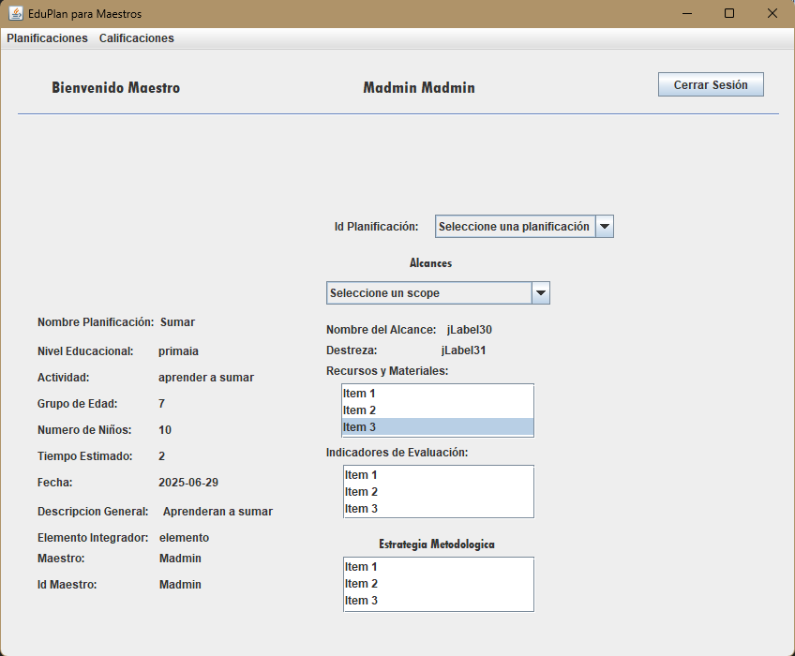

*Ver todas mis Planificaciones*

Click the "Update" button to display all available plans.

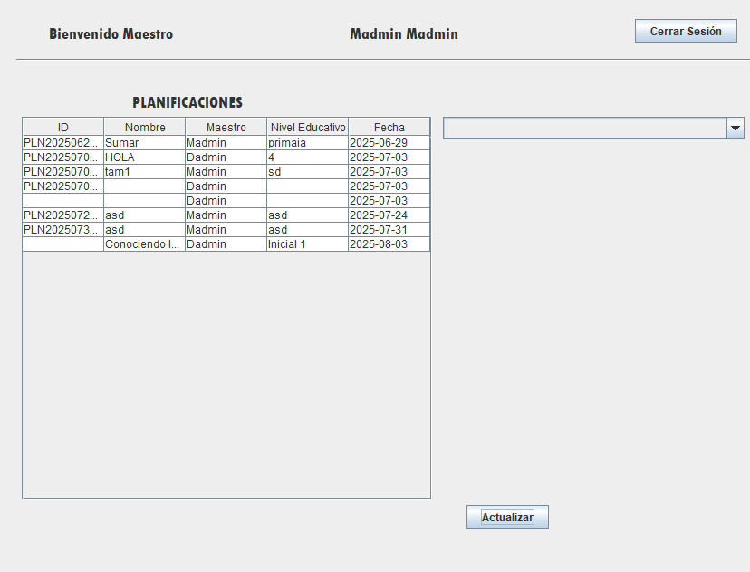

**CALIFICACIONES MODULE**

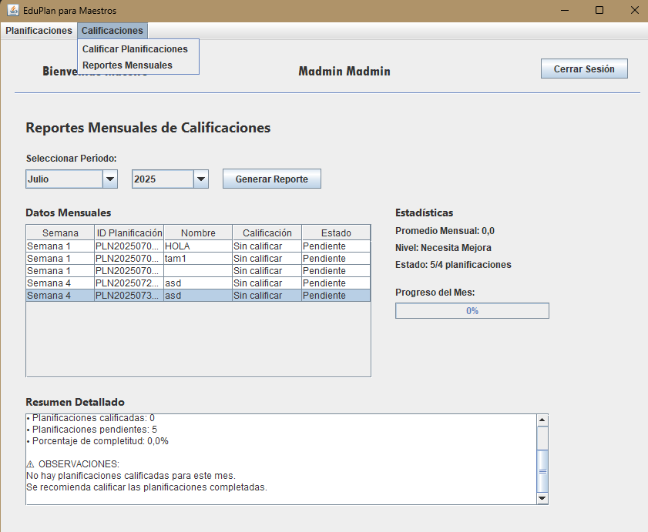

*Calificar Planificaciones*

Select the plan you want to grade.

Use your mouse to assign a grade based on knowledge retention.

Click "Grade" to save the result

.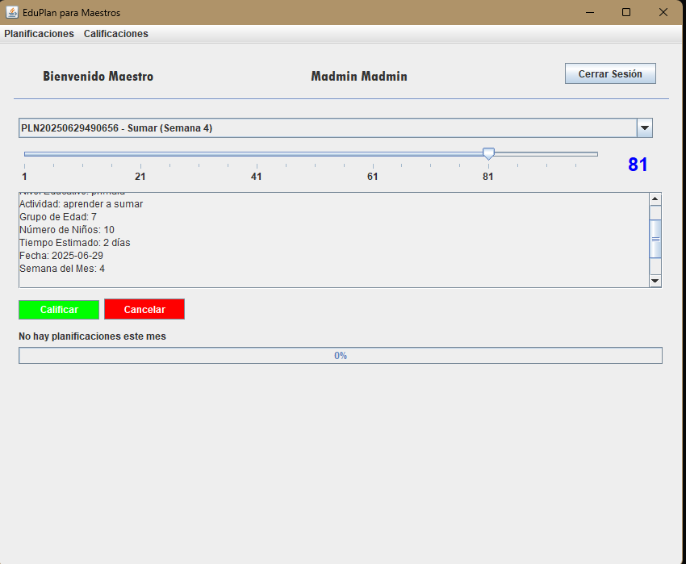

*Reportes mensuales*

Select a month and year, then click "Generate Report" to view the metrics for that specific period.

